CSS Selectors & Styling

Theory Assignment

Q.1 What is a CSS Selector? Provide examples of element, class, and ID selectors.
Ans: A CSS Selector is a pattern used to select the HTML elements you want to style. It tells the browser which elements the CSS rules should apply to.
Types of CSS Selectors with Examples:
- Element Selector: Targets all elements of a specific type.
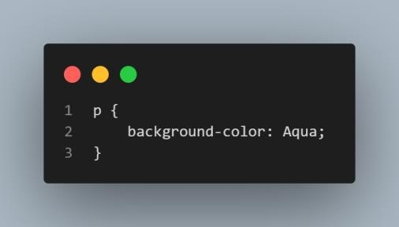
- Class Selectors: Targets all elements with a specific class attribute (Start with .dot). This applies styles to any element with class=” Intro”.
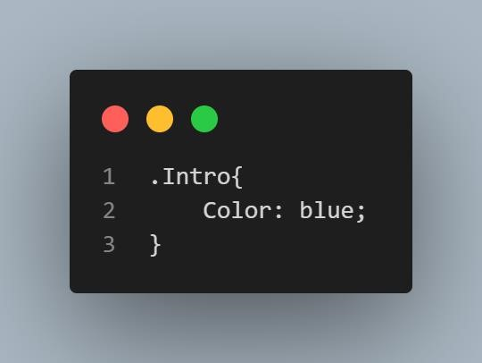
- ID Selectors: Targets a single element with a specific ID (starts with a hash#). IDs must be unique in a page. This applies style only to the element with id=” header”.
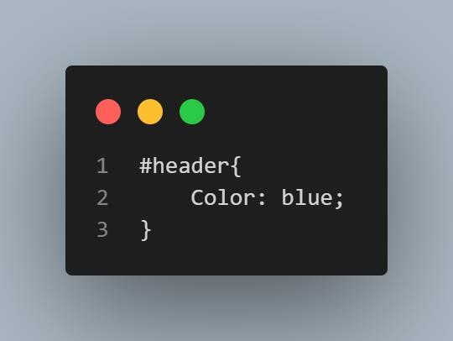

Q.2 Explain the concept of CSS specificity. How do you conflict between multiple styles get resolved?
Ans: CSS specificity is a set of rules that determines which style rule takes precedence when multiple rules apply to the same HTML element.
Specificity Hierarchy Chart:

Selector type | Specificity value
Universal * | 0,0,0,0
Element / Tag (p, h1) | 0,0,0,1
Class (.class) | 0,0,1,0
Attribute ([type = “text”]) | 0,0,1,0
Pseudo-class (: hover) | 0,0,1,0
ID (#id) | 0,1,0,0
Inline styles (style=” “) | 1,0,0,0
!important | Overrides all (except another !imp with higher  specificity)

How conflicts get resolved:
If two or more CSS rules target the same element, the rule with higher specificity wins. If specificity is equal, the last declared rule in the CSS take precedence.

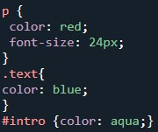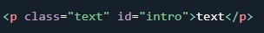

The Final colour will be Red because:
P selector has 0,0,0,1
.text class has 0,0,1,0 and
#intro ID has 0,1,0,0 has highest specificity

Q.3 What is the difference between internal, external, and inline CSS? Discuss the advantages and disadvantages of each approach.
Ans:

Feature | Inline CSS | Internal CSS | External CSS
Location | Inside the HTML element using the style attribute. | Inside a <style> tag in the <head> section. | In a separate .css file linked with a <link> tag.
Scope | Affects only that specific element. | Affects multiple elements on a single page. | Affects multiple pages across an entire website.
Priority | Highest; overrides others. | Medium; overrides external. | Lowest; can be overridden by others.

1. Inline CSS
Styles are applied directly to a single HTML tag. It is best for quick fixes or unique overrides but becomes difficult to maintain as projects grow.
Example: <h1 style="colour: blue;">Hello World</h1>
2. Internal CSS (Embedded)
Styles are placed within the HTML document's <head>. This is useful for single-page sites or landing pages where you don't need a separate file.

- Inline CSS: CSS directly written inside an html tag. ex: <p style=” font-size: 25px;”> </p>

ADVANTAGES:
  - Quick and easy for small changes.
  - Good for testing or one-time fixes.

DISADVANTAGES:
  - Hard to manage if you have lots of elements.
  - Makes your HTML messy.
  - Not reusable – you have to repeat the style again and again.
- Internal CSS: CSS is written inside the <style> tag in the <head> section of the html file.
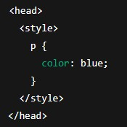

ADVANTAGES:
  - Keeps all the CSS for one page in one place.
  - Easier to manage than Inline CSS.
DISADVANTAGES:
  - Only works for that one page.
  - Not ideal for large websites with many pages.
  - Slows things down if you repeat styles across multiple pages.

- External CSS: CSS is written in separate .css file, and you link it in your HTML.

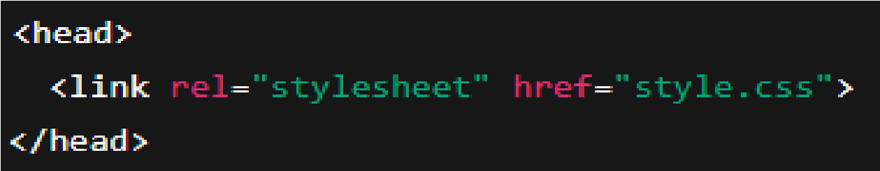

ADVANTAGES:
  - Clean and organized – HTML and CSS are kept separate.
  - Reuse the same CSS file across many pages.
  - Faster for the browser after the first load.
  - Best for larger or multi-page websites.
DISADVANTAGES:
  - Needs an extra file, so the page might load a bit slower the first time.
  - If the CSS file doesn’t load, styles won’t show.

